DATE / TIME:  September 17, 2025  11:30 AM - 2:00 PM | LOCATION:  Tustin Presbyterian Church  225 Main Street  Tustin, CA 92780 |  | 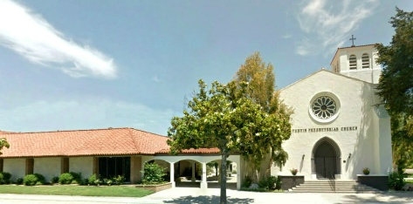
MEETING TOPIC:

Polypharmacy in Geriatric Care and CDC 2025 Flu Vaccination Update

AGENDA |  | TIME
Sign-In and Lunch |  | 11:30 AM
Welcome: Susan Johnson, RN-BC, MPH  Reflection: Juliana Emina-Coney, MASL, RN |  | 11:45 AM  11:50 AM
Featured Speakers:  Ryan Bui, PharmB  Hoag Pharmacy Resident  Anne Zakhrious, PharmD  Hoag Pharmacy Resident  myCavax/MyTurn Training:  Beth Otterbein, BSN, RN  FCN Announcements: ALL |  | 12:00 PM  1:00 PM  2:00 PM
Course Description
This presentation will explore the risks of polypharmacy - a practice of overprescribing patients with medications, resulting in higher risk of patient safety consequences such as drug interactions, adverse events, and hospitalization. We will review the causes of polypharmacy, medications with high risk of elderly adverse events per the American Geriatrics Society (AGS) Beer’s Criteria, and preventative course of actions that can be taken. By the end of the session, you will understand signs of polypharmacy and identify high-risk medications for geriatric patients to optimize patient safety and medication management.
The session will also review the 2025 Center for Disease Control and Prevention (CDC) Immunization Guidelines for adults and special populations. The guidelines will also highlight the most recent recommendations made by the Advisory Committee on Immunization Practices (ACIP). We will discuss some case-based examples related to both medication reconciliation and immunizations.
Learning Objectives: At the conclusion of this presentation, participants will be able to:
- Explain the causes behind polypharmacy, the risks in patient safety outcomes from adverse drug reactions, and preventative course of action to minimize patient harm.
- Evaluate the medications that increase geriatric patient risk through the American Geriatric Society Beer’s criteria and the recommended alternative medications for treatment.
- Identify appropriate vaccines based on age and/or medical conditions as determined by the 2025 Center for Disease Control and Prevention (CDC) Guidelines.

*This course has been approved for 1.0 Continuing Education Units [CEU] for Registered Nurses, CA BRN Provider Number 17163. An email will be sent after the meeting with the evaluation questions. You will immediately receive your CEU certificate from CloudCME upon completion of evaluation.

Special Birthdays –August: Beth Otterbein (8/14), Julie Green (8/14), Sandra Jones (8/20)
September: Audrey Henry (9/2), Vivian Derr (9/10), Brenda Schisler (9/16), Carol McCann (9/20)

SPECIAL THANKS to Ryan Bui, PharmB; Anne Zakhrious, PharmD; Juliana Emina-Coney, MASl, RN; and Tustin Presbyterian Church for their generosity and support of Hoag Faith Community Nursing (FCN). We appreciate ALL you do!

NO OCTOBER MEETING! Next Meeting: November 19, 2025, 11:30am- 2:00 pm— Eastern Medicine &Acupuncture with Dr. Nam Lee, Functional Medicine/Acupuncturist. Location is at Trinity Episcopalian Church, 2400 N. Canal, Orange, CA 92865.



